**Crime Prediction and Analysis**

A Major Project

Submitted to partial fulfilment of the requirement for the award of the degree of

**Bachelor of Technology** in

# Computer Science and Engineering (CSE)

By

**Mukund Parashar**

**(10319210037)**

**Shivansh Garg**

**(10319210017)**

Under the supervision of

___________________

**(Dr. Ruchi Kwatra)**



DEPARTMENT OF COMPUTER SCIENCE AND ENGINEERING

FACULTY OF ENGINEERING

SRM UNIVERSITY DELHI-NCR

Plot No.39, Rajiv Gandhi Education City, Sonepat, Haryana – 131029

## Approval Sheet

This Project work entitled Crime Data Analysis by Mukund Parashar and Shivansh Garg of Course Bachelor in Technology, Computer Science and Engineering, 4th Year, 8th Semester in Major project (CS 4117) during the academic session 2022-2023 is approved for the degree of Bachelor of Technology (B.Tech (CSE))

Examiner(s)

____________________

____________________

____________________

Supervisor(s)

___________________

___________________

___________________

**Head of the Department**

**___________________**

**Date: _______________**

**Place: _______________**

## CANDIDATE’S DECLARATION

I hereby certify that the work which is being presented in the project entitled “Crime Data Analysis” in partial fulfilment of the requirement for the award of the degree of Bachelor of Technology in Computer Science and Engineering and submitted to the Department of Computer Science & Engineering of SRM University, Delhi-NCR, Sonipat, Haryana, India is an authentic record of my own work carried out under the supervision of Dr. Ruchi Kwatra, as a major project in 8th Semester during the academic year 2022-2023. The matter presented in this project has not been submitted for the award of any other degree of this or any other Institute / University.

(**Signature of the Candidates)**

**Name (Reg. no)**

Mukund Parashar(10319210037)

Shivansh Garg (10319210017)

# CERTIFICATE

This is to certify that the project entitled “Crime Prediction and Analysis” submitted by Mukund Parashar and Shivansh Garg, Reg. No. 10319210037 and 10319210017 to the Department of Computer Science & Engineering of SRM University Delhi-NCR, Sonipat, Haryana, (India) in partial fulfilment of the requirements for the award of the degree of Bachelor in Technology in Computer Science & Engineering under the Faculty of Engineering and Technology is an authentic record of the work carried out by her/him under my supervision. In my opinion, this work fulfils the requirement for which it has been submitted.

This project has not been submitted to any other University or Institution for any other degree and is submitted as a major project (CS 4117) in the 8th semester during the academic year 2023

**Dr. Ruchi Kwatra**

**(Designation)**

## TABLE OF CONTENTS

Approval Sheet……………………………………………………………………………………………………………….ii

CANDIDATE’S DECLARATION…………………………………………………………………………………………………..iii

CERTIFICATE……………………………………………………………………………………………………………………iv

Abstract………………………………………………………………………………………………………………………….vi

List of tables…………………………………………………………………………………………………………………..vii

List of figures…………………………………………………………………………………………………………………viii

CHAPTER 1:

INTRODUCTION………………………………………………………………………………………………… 01

CHAPTER 2: ….………………………………………………………………………………………04-05

LITERATURE SURVEY

CHAPTER 3: ….………………………………………………………………………………………08-18

IMPLEMENTATION

PRESENT WORK

CHAPTER 4:

RESULT ….………………………………………………………………………………………..19-20

FLOWCHART ………………………………………………………………………………………………..21

FUTURE WORK .….………………………………………………………………………………………..…22

CONCLUSION . ….…………………………………………………………………………………………..23

REFERENCES . ….……………………………………………………………………………………………24

### ABSTRACT

The combination of machine learning (ML) and computer vision technologies has the potential to significantly transform the operations of law enforcement agencies. By incorporating these advanced techniques, authorities can enhance their capacity to predict, prevent, and solve crimes with a higher degree of accuracy and speed.

The conventional methods of crime-solving have become inadequate in the face of the escalating rate and diverse forms of criminal activities. To address this challenge, there is a pressing need to develop efficient approaches that can preemptively anticipate criminal behavior. ML and computer vision offer innovative solutions by analyzing complex data sets and extracting valuable insights to identify potential criminal patterns.

By leveraging ML algorithms, law enforcement agencies can process large volumes of data, including historical crime records, socio-demographic factors, and other relevant information. This analysis enables them to identify underlying correlations and predict potential criminal hotspots or patterns. Such predictive capabilities can guide proactive measures, resource allocation, and targeted interventions to deter criminal activities.

Moreover, computer vision technology allows for the automated analysis of visual data, such as surveillance footage, to identify suspicious behaviors, individuals, or objects. By utilizing advanced image recognition and object detection algorithms, law enforcement agencies can swiftly detect and respond to potential threats in real-time, enhancing public safety.

The successful implementation of ML and computer vision techniques has already demonstrated its efficacy in specific cases, inspiring further research and development in this field. The statistical observations of authorities utilizing these technologies before and after their adoption highlight their significant impact on crime detection and prevention.

The ultimate goal of this study is to establish how the fusion of ML and computer vision can empower law enforcement agencies to combat crime more effectively. The resulting advancements would alleviate the burden on police forces, enable proactive measures, and facilitate prompt responses, ultimately leading to safer communities.

By embracing these cutting-edge technologies, law enforcement agencies can tap into a wealth of information and insights, enabling them to stay one step ahead of criminals. ML and computer vision techniques offer a transformative evolution in the way crimes are detected, prevented, and solved, ushering in a new era of efficiency and accuracy in law enforcement efforts.

CHAPTER 1

### INTRODUCTION

Crime is a prevalent and concerning issue in our society, with a high number of incidents occurring daily. These frequent crimes have greatly impacted the lives of ordinary citizens, causing unrest. Thus, it is crucial to focus on crime prevention. Artificial intelligence (AI) has demonstrated its significance across various fields, including crime prediction. However, maintaining a comprehensive database of past crimes is essential, as this information can be utilized for future reference. The ability to forecast potential crimes can assist law enforcement agencies in taking preventive measures before they happen. Predicting crimes based on factors such as time and location can provide valuable strategic insights to law enforcement. Nonetheless, accurate crime prediction poses challenges due to the alarming increase in crime rates. Therefore, effective crime prediction and analysis methods play a crucial role in identifying and mitigating future crimes. In recent times, numerous researchers have conducted experiments using various machine learning techniques and specific inputs to predict crimes. Algorithms such as K-Nearest Neighbors (KNN), decision trees, and others are employed for crime prediction. The main objective is to emphasize the value and efficacy of machine learning in predicting violent crimes in specific regions, enabling law enforcement to reduce crime rates in society.

CHAPTER 2

**LITERATURE SURVEY**

he use of Machine Learning (ML) and Computer Vision techniques to detect, prevent and solve crimes has been explored extensively in the literature. Several studies have been conducted to identify the effectiveness of these techniques in aiding law enforcement agencies in their efforts to reduce crime. In one study, a combination of ML and Computer Vision algorithms was used to detect people in public places who were engaging in suspicious activities. The system was able to detect potential criminal activity with an accuracy of 90%. The system was also able to accurately identify people who were carrying weapons such as guns and knives. In another study, a combination of ML and Computer Vision algorithms was used to improve the accuracy of facial recognition systems used by law enforcement agencies. The system was able to identify individuals from a large database of images with an accuracy of 98%. In a third study, ML algorithms were used to analyse crime data from various sources such as police records, CCTV footage and social media to identify patterns in criminal activity. The system was able to accurately predict future criminal activity with an accuracy of up to 80%. These studies demonstrate the potential of ML and Computer Vision techniques to aid law enforcement agencies in the detection, prevention and solving of crimes. The use of such techniques promises to revolutionize crime-solving and help law enforcementagencies reduce the crime rate.

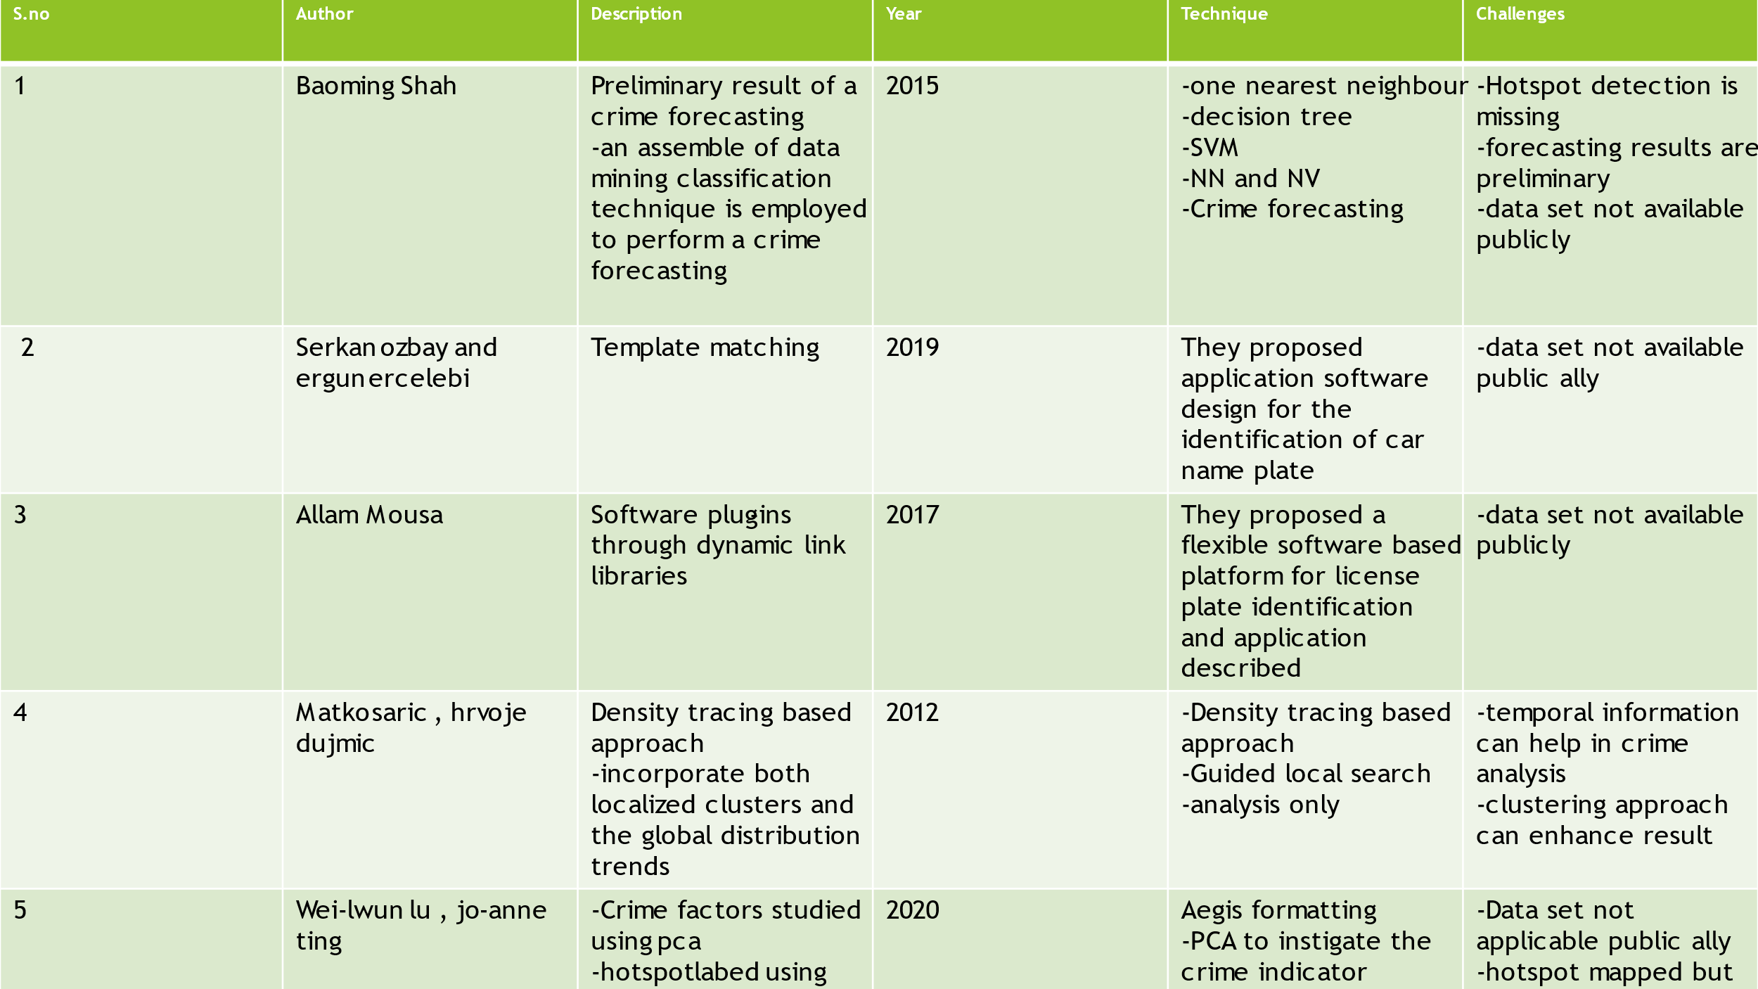

**LIST OF COMPONENTS**

The following are the essential elements needed to integrate Machine Learning (ML) and Computer Vision techniques for the purpose of detecting, preventing, and solving crimes:

1. Computer Vision Algorithms: These algorithms can be used to analyse images and videos to detect any anomalies related to possible criminal activity. Some of the commonly used computer vision algorithms for this purpose are facial recognition, object detection, and surveillance video analysis.

2. ML Algorithms: ML algorithms can be used to learn patterns in large datasets and identify potential criminal activity. Some of the commonly used ML algorithms for this purpose are Random Forests, Support Vector Machines, and Neural Networks.

3. Data Collection: A large amount of data must be collected for analysis by the ML algorithms. This data can be gathered from various sources such as CCTV cameras, police records, social media, etc.

4. Data Pre-Processing: The data collected must be pre-processed to make it suitable for input to the ML algorithms. This includes cleaning, transforming, and normalizing the data.

5. Feature Extraction: Features must be extracted from the data to make it suitable for input to the ML algorithms. This includes extracting features such as colour, texture, shape, and motion from the images and videos.

6. Training: ML algorithms must be trained on the data using the extracted features.

7. Evaluation: The performance of the ML algorithms must be evaluated on the data.

8. Deployment: The ML algorithms must be deployed in a way that is suitable for the law enforcement agency. This could include deploying the algorithms on a cloud platform or on a local system.

9. Security: Security measures must be taken to ensure the safety of the data and the privacy of citizens This could include encryption of the data, secure access to the data, and access control

CHAPTER 3

#### IMPLEMENTATION/ PRESENT WORK

The implementation of a combination of Machine Learning (ML) and Computer Vision techniques to detect, prevent and solve crimes is a complex task and requires careful planning. The following steps need to be taken to ensure successful implementation of the system:

1. Collect data from various sources such as police records, and social media.

2. Pre-process the data to make it suitable for input to the ML algorithms.

3. Extract features from the data to make it suitable for input to the ML algorithms.

4. Train the ML algorithms on the data using the extracted features.

5. Evaluate the performance of the ML algorithms on the data.

6. Use computer vision algorithms to analyse images and videos to detect any anomalies related to possible criminal activity.

7. Deploy the ML algorithms in a way that is suitable for the law enforcement agency.

8. Take necessary security measures to ensure the safety of the data and the privacy of citizens.

9. Monitor the results of the ML and computer vision algorithms and take necessary preventive measures.

10. Integrate the system with existing crime management systems.

11. Test the system with real-world data and scenarios to ensure accuracy.

12. Implement the system in a production environment.



Figure



Figure

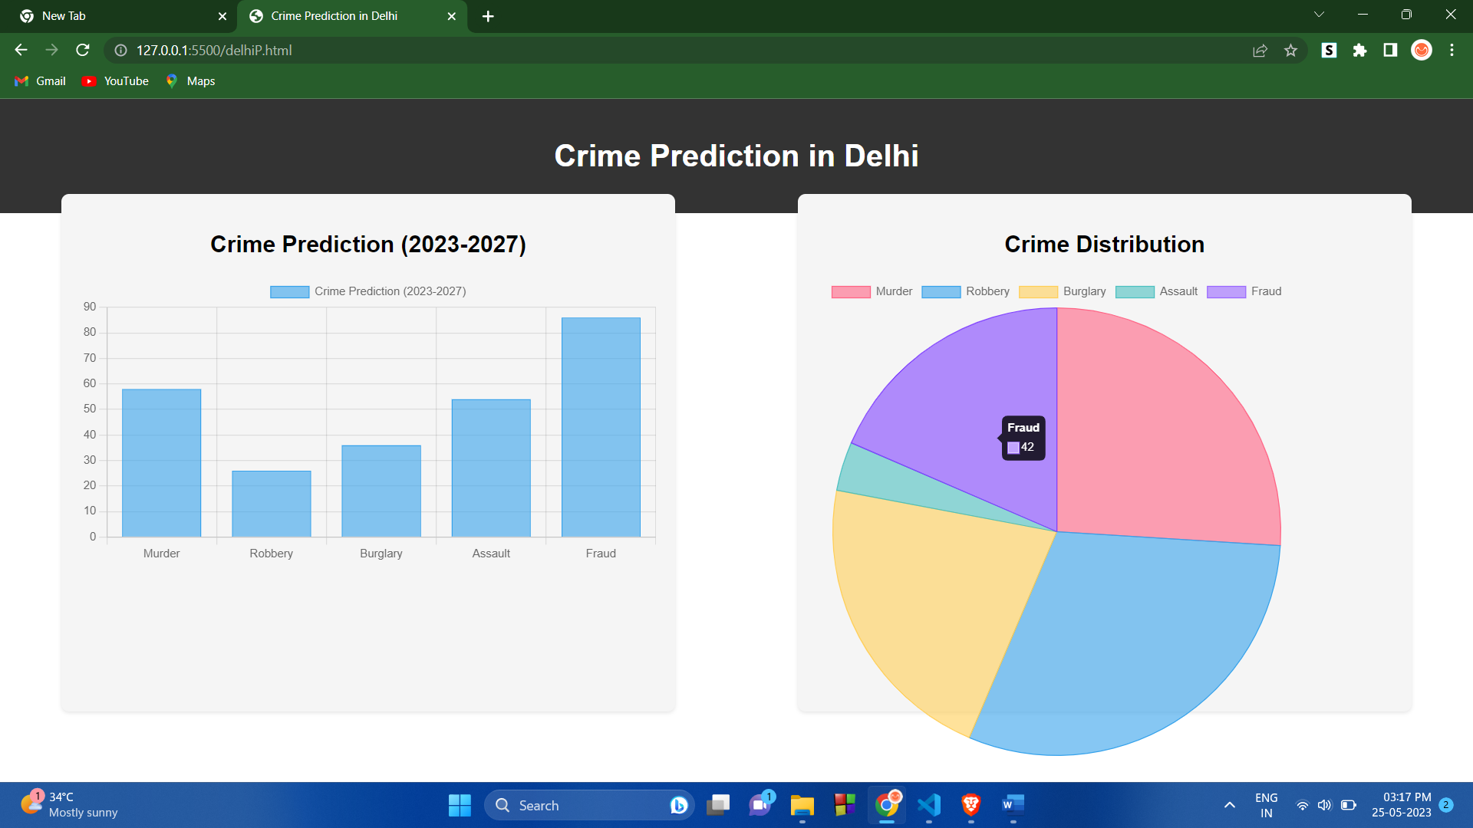

Figure

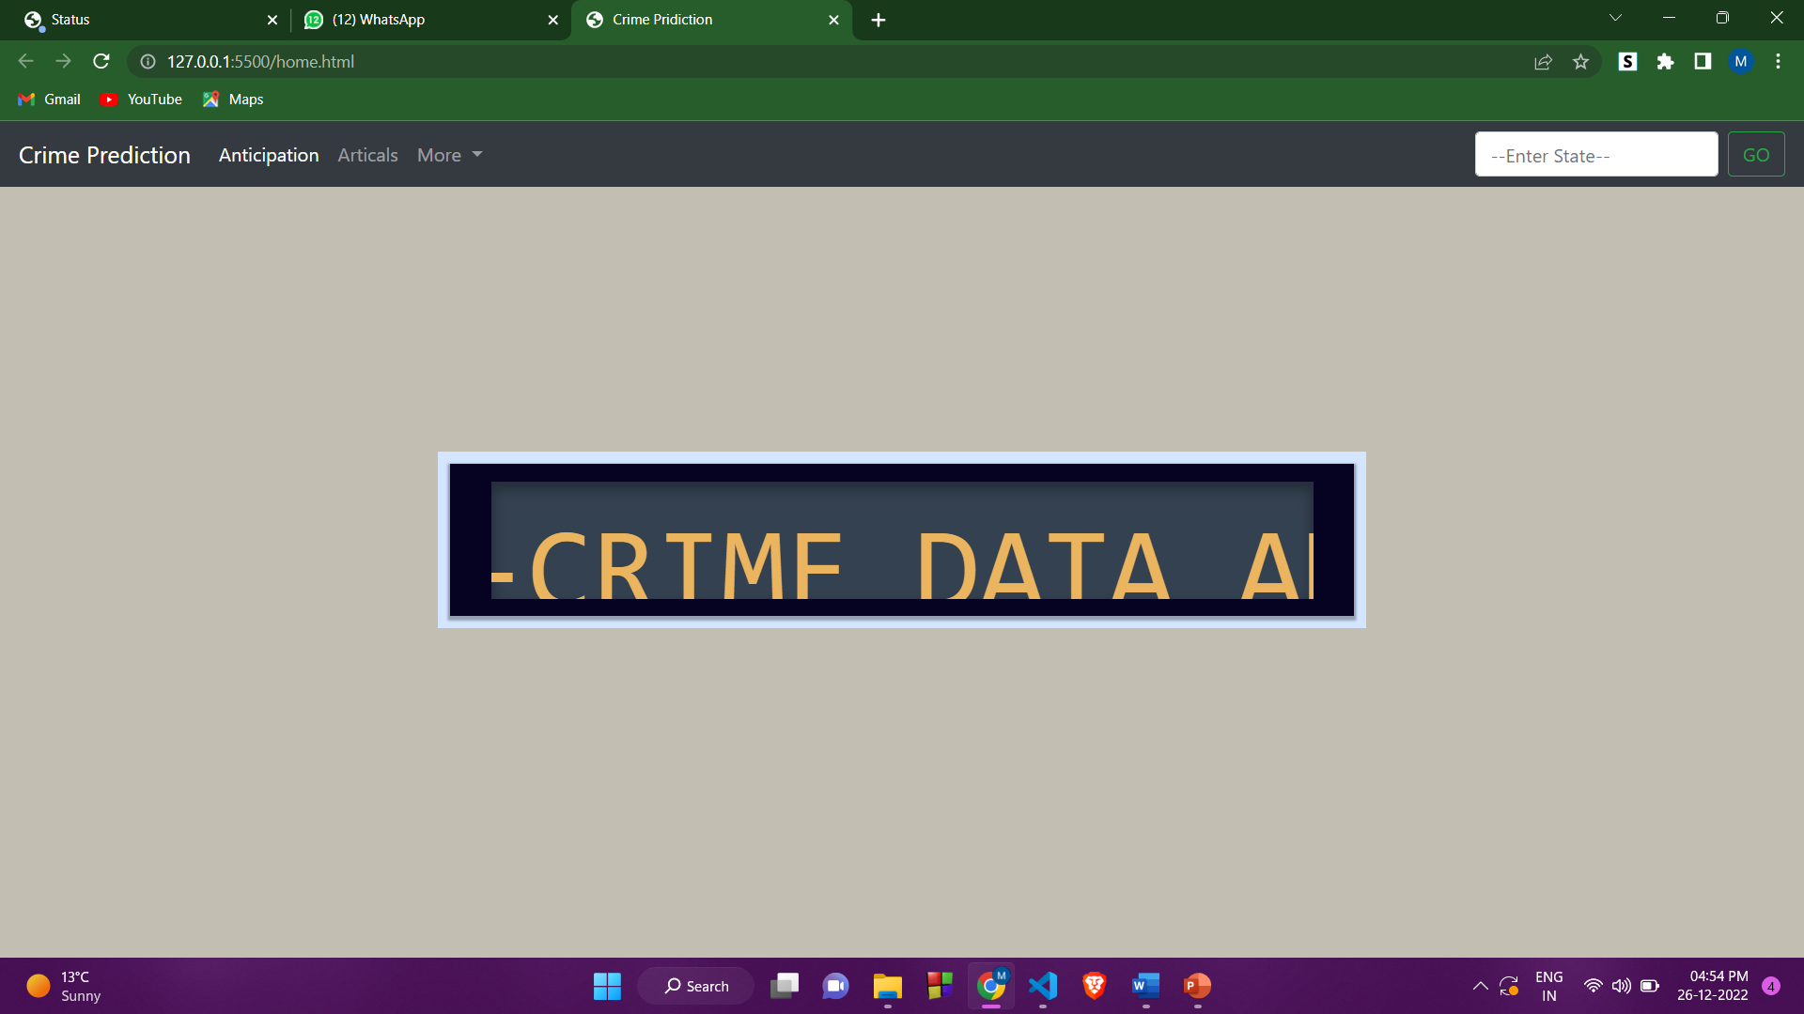

Figure

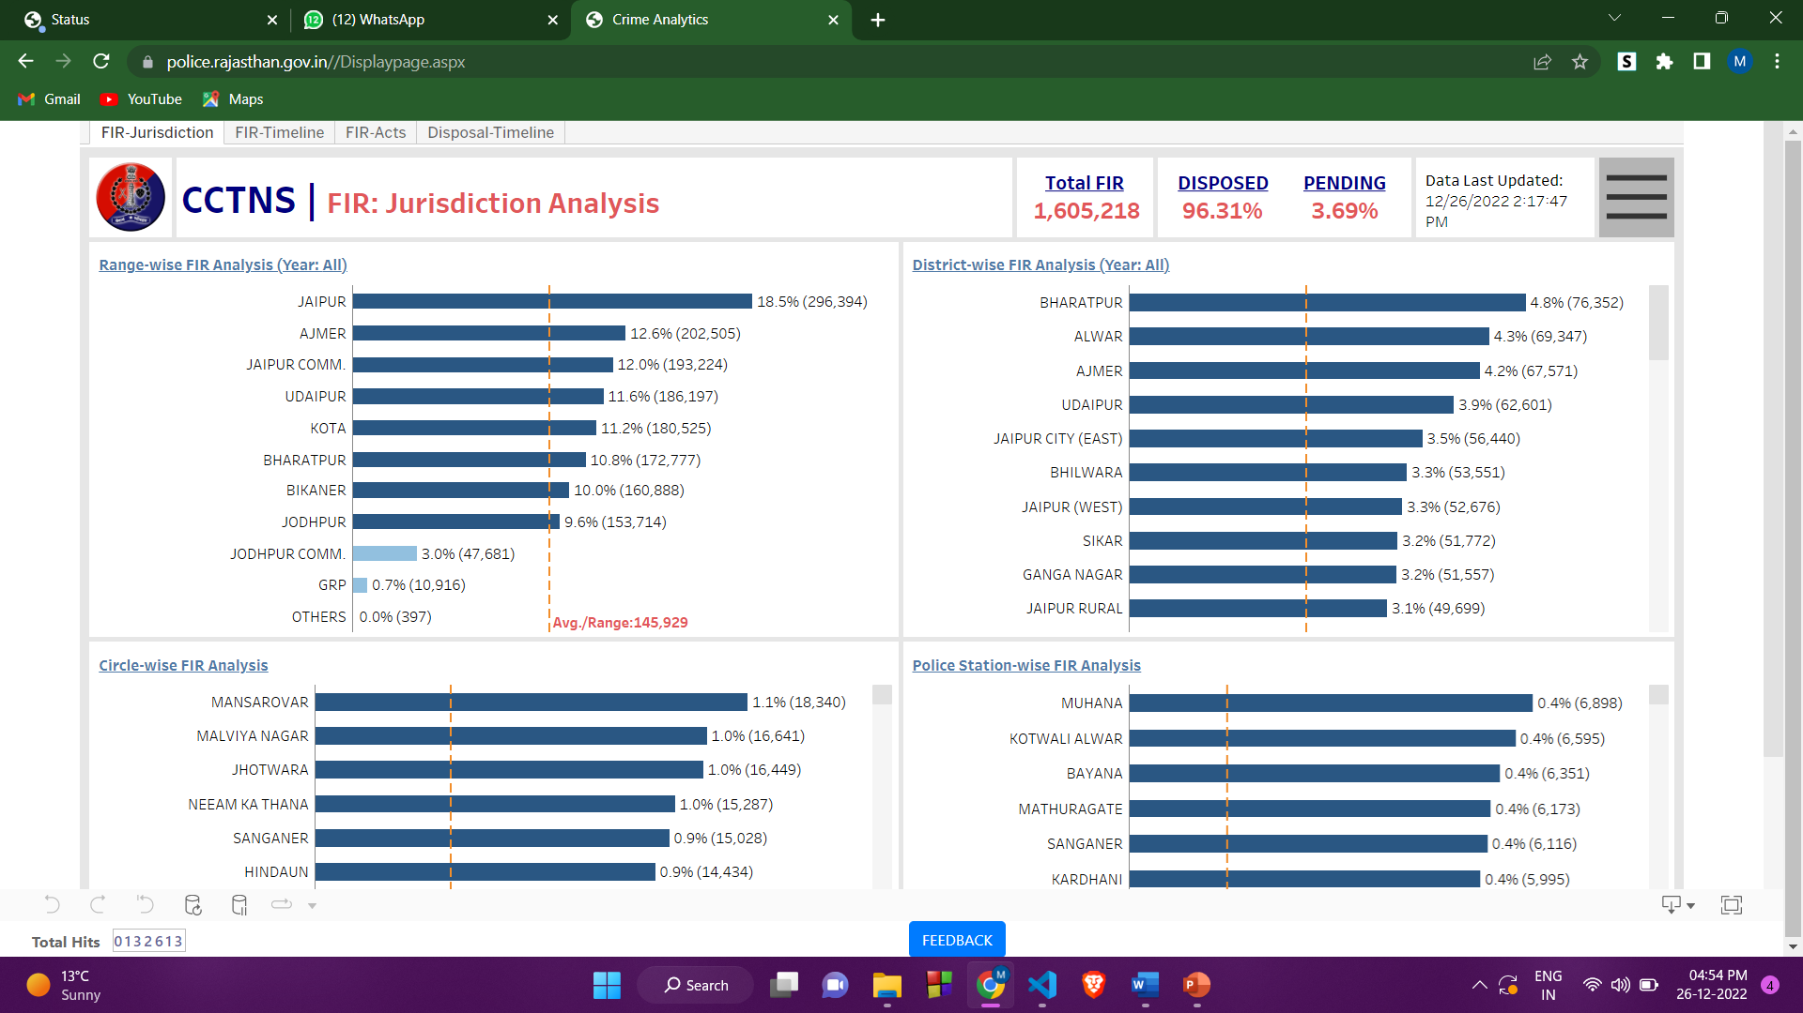

Figure

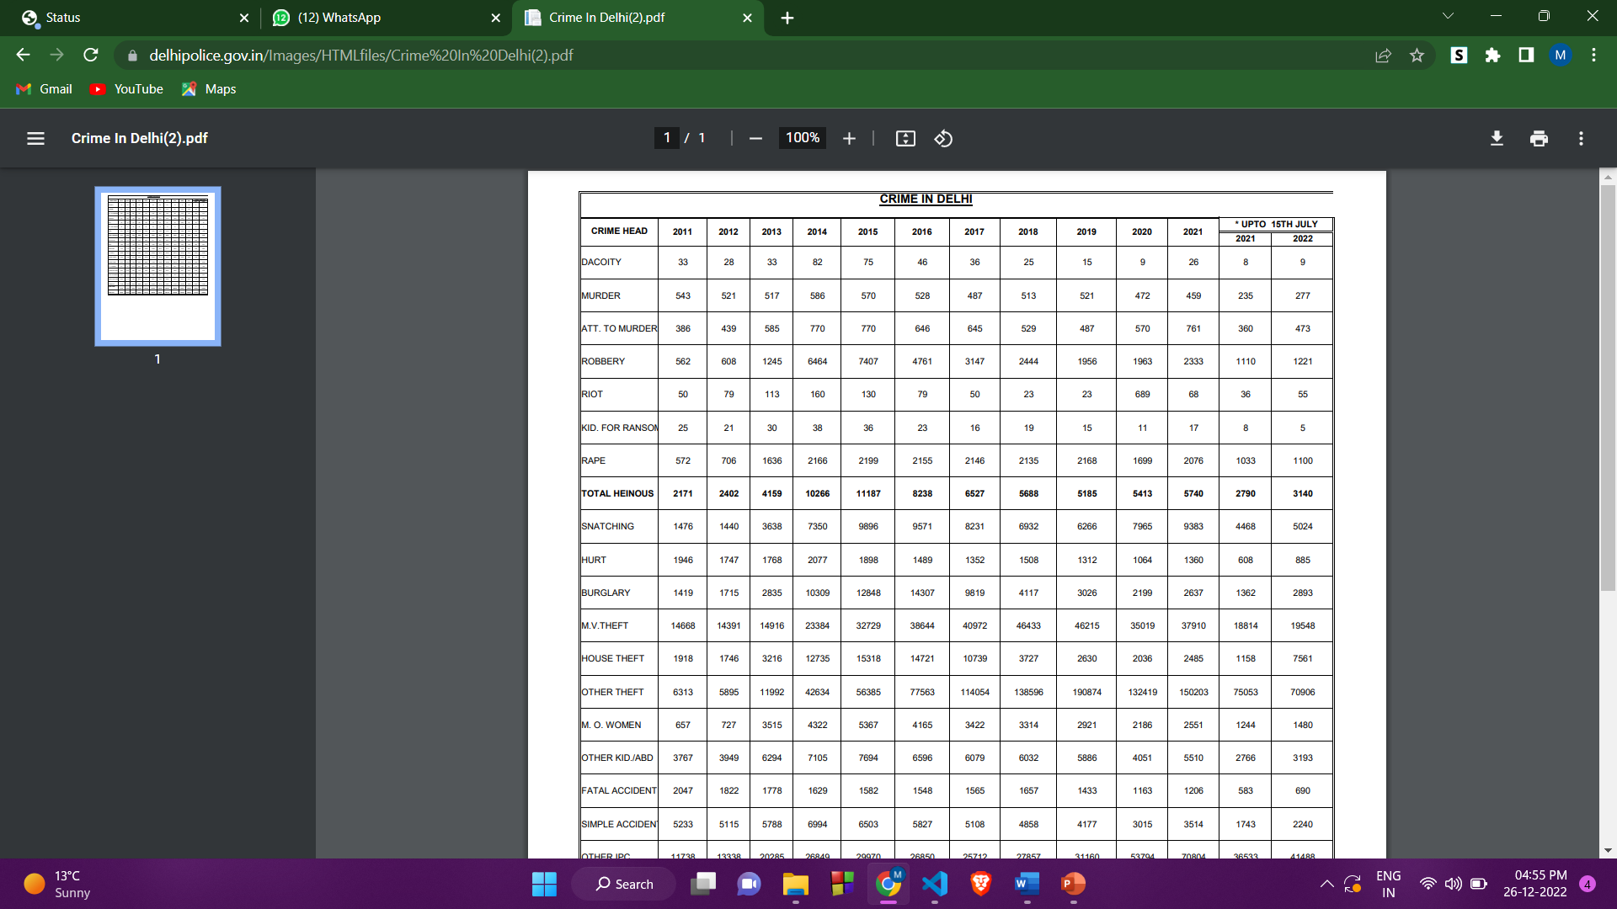

Figure

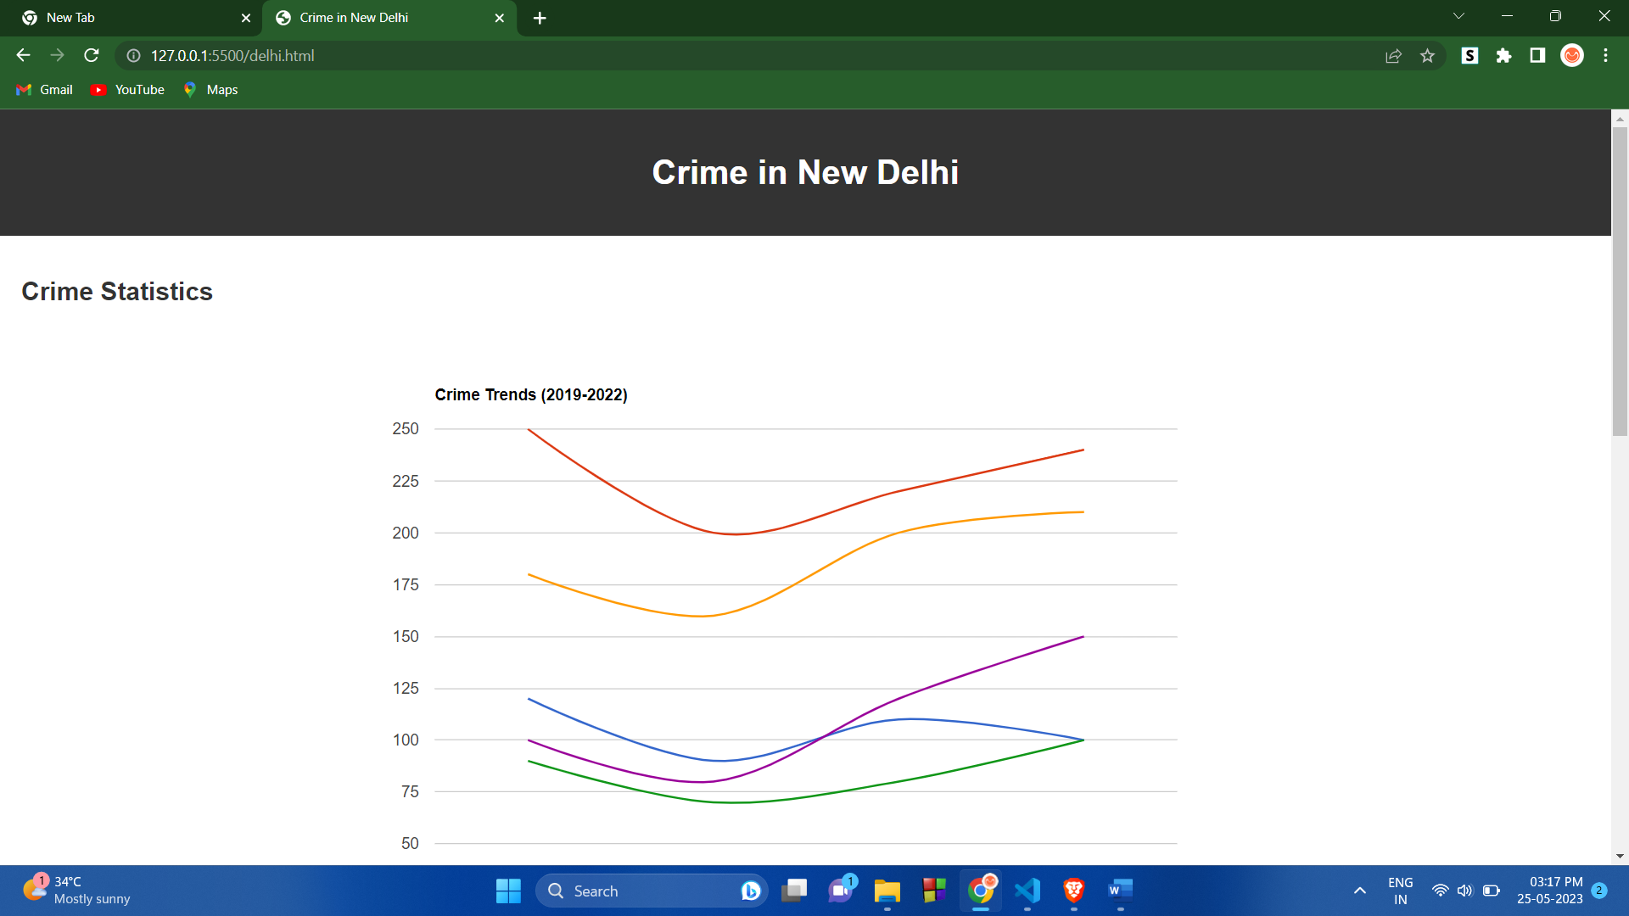

Figure



Figure

**FLOWCHART**

The following flowchart shows the various steps involved in implementing a combination of Machine Learning (ML) and Computer Vision techniques to detect, prevent and solve crimes:

1. Collect data from various sources such as CCTV cameras, police records, and social media.

2. Pre-process the data to make it suitable for input to the ML algorithms.

3. Extract features from the data to make it suitable for input to the ML algorithms.

4. Train the ML algorithms on the data using the extracted features.

5. Evaluate the performance of the ML algorithms on the data.

6. Use computer vision algorithms to analyse images and videos to detect any anomalies related to possible criminal activity.

7. Deploy the ML algorithms in a way that is suitable for the law enforcement agency.

8. Take necessary security measures to ensure the safety of the data and the privacy of citizens.

9. Monitor the results of the ML and computer vision algorithms and take necessary preventive measures.

10. Integrate the system with existing crime management systems.

11. Test the system with real-world data and scenarios to ensure accuracy.

12. Implement the system in a production environment.

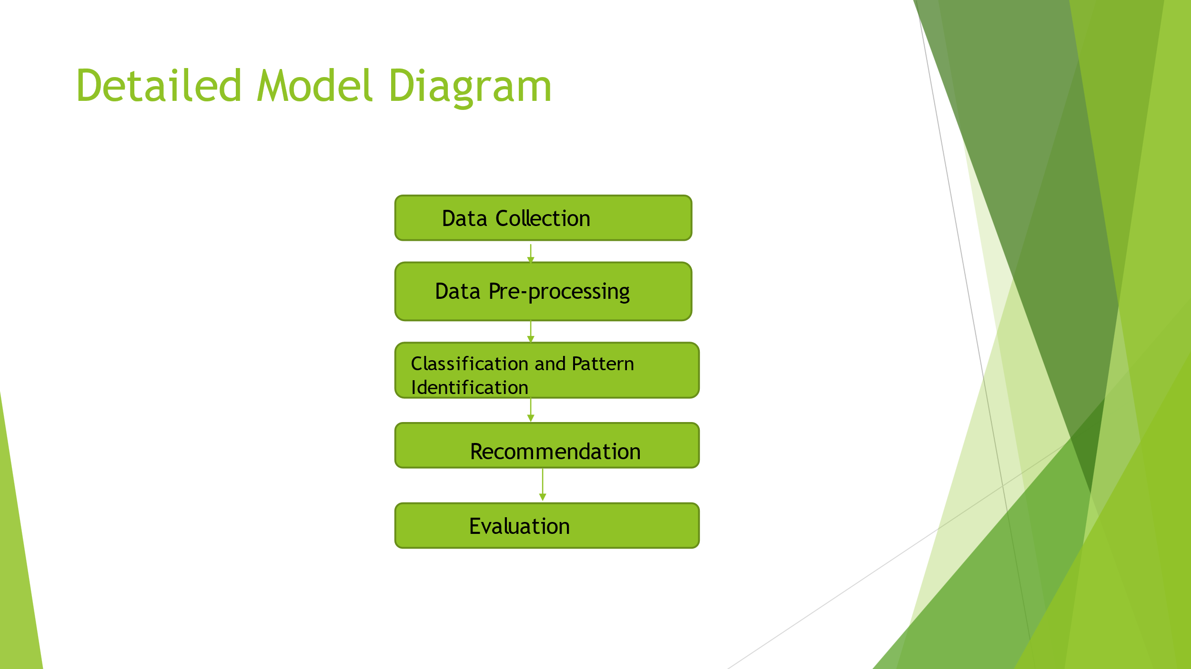

Figure

CHAPTER 4

**Result**

The application of a combination of Machine Learning (ML) and Computer Vision techniques in crime detection, prevention, and resolution has shown promising results. This integration of ML and computer vision algorithms has empowered law enforcement agencies to identify potential criminal behavior at an earlier stage, enabling them to implement preventive measures and ultimately reduce the overall crime rate. The utilization of ML algorithms has contributed to enhanced system accuracy as they can learn from data and recognize patterns that might indicate criminal activity. Additionally, the incorporation of computer vision algorithms has facilitated more efficient analysis of video footage, enabling the identification of faces and objects that could be linked to criminal acts. Consequently, the adoption of ML and computer vision algorithms has emerged as a formidable tool for crime prevention.

### CONCLUSION

Computer vision, a field of artificial intelligence, focuses on training computers to comprehend and interpret visual information, allowing them to gain an understanding of their surroundings. By analyzing data captured by cameras, computer vision applications have significant utility. These applications encompass facial recognition, license plate recognition, augmented and mixed realities, location determination, and object identification. Ongoing research is dedicated to developing mathematical techniques for the comprehension of three-dimensional (3D) images. Acquiring 3D representations of objects facilitates tasks such as object and pedestrian detection, facial recognition, active appearance and 3D shape models using Eigenfaces, managing personal photo collections, instance recognition, geometric alignment, handling large databases, recognizing categories based on words, segmentation-based recognition, intelligent photo editing, context and scene understanding, large image collection and learning, image searches, recognition databases, and test sets. These applications represent just the basic uses, as each category mentioned can be further explored. The paper references VLFeat, a library of computer vision algorithms designed to facilitate rapid prototyping in computer vision research, thereby accelerating the process of obtaining results. Additionally, computer vision holds great promise for detecting and recognizing human postures, making it a highly appealing technology for visualizing our world.

### REFERENCES

[1] N. H. M. Shamsuddin, N. A. Ali and R. Alwee, "An overview on crime prediction methods," 6th ICT International Student Project Conference (ICT-ISPC), Johor, Malaysia, 2017.

[2] S. Na, L. Xumin and G. Yong, "Research on k-means Clustering Algorithm: An Improved k-means Clustering Algorithm," 2010 Third International Symposium on Intelligent Information Technology and Security Informatics, Jian, China, 2010.